**TASK # 1:**

**Create basic calculator application on Console Application that perform basic arithmetic operations like (add, subtract, multiply, divide).**

**CODE:**

namespace Calculator

{

class Program

{

static void Main(string[] args)

{

string option;

Console.WriteLine("\t*** Simple Calcultor ***");

Console.WriteLine();

do

{

Console.WriteLine("---------------------------------------------");

Console.Write("Enter First Value: ");

int value1 = int.Parse(Console.ReadLine());

Console.Write("Enter Second Value: ");

int value2 = int.Parse(Console.ReadLine());

Console.WriteLine("---------------------------------------------");

Console.WriteLine("Select option : ");

Console.WriteLine("[1] - Add");

Console.WriteLine("[2] - Subtract");

Console.WriteLine("[3] - Multiply");

Console.WriteLine("[4] - Divide");

Console.WriteLine("---------------------------------------------");

int select = int.Parse(Console.ReadLine());

Console.WriteLine("---------------------------------------------");

if (select == 1)

{

Console.WriteLine("Addition result = {0} + {1} = {2}",value1,value2,(value1+value2));

}

else if (select == 2)

{

Console.WriteLine("Subtraction result = {0} - {1} = {2}", value1, value2, (value1 - value2));

}

else if (select == 3)

{

Console.WriteLine("Multiplication result = {0} * {1} = {2}", value1, value2, (value1 * value2));

}

else if (select == 4)

{

Console.WriteLine("Division result = {0} / {1} = {2}", value1, value2, (value1 / value2));

}

else

{

Console.WriteLine("Invalid Input");

}

Console.WriteLine("---------------------------------------------");

Console.WriteLine("Do you want to Continue yes or no");

option = Console.ReadLine();

} while (option=="yes");

Console.WriteLine("Good Bye........!");

Console.ReadLine();

}

}

}

**OUTPUT:**

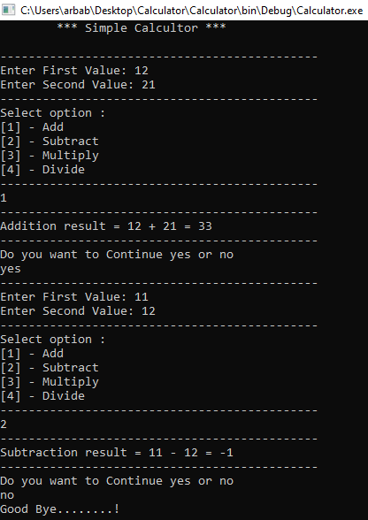

**TASK # 2:**

**Create Winform application that authenticate user with hardcoded username and password if user authenticated new form will be open that takes user information as an input and on button click all information will be displayed in dialog box.**

**CODE:**

**Login Button:**

private void button1_Click(object sender, EventArgs e)

{

if (textBox1.Text == "Arbab" && textBox2.Text == "12345")

{

this.Hide();

PersonalInfo PI = new PersonalInfo();

MessageBox.Show("login Successfully...!");

PI.Show();

}

}

**Close Button:**

private void button2_Click(object sender, EventArgs e)

{

this.Close();

}

**Save Button:**

private void button1_Click(object sender, EventArgs e)

{

MessageBox.Show("Full Name = "+textBox1.Text+" "+textBox2.Text+"\n"+"Phone No = "+textBox3.Text+"\n"+"Email = "+textBox4.Text,"User Information");

}

**OUTPUT:**

